Hands-on 1: Create a Spring Web Project using Maven

Project Configuration
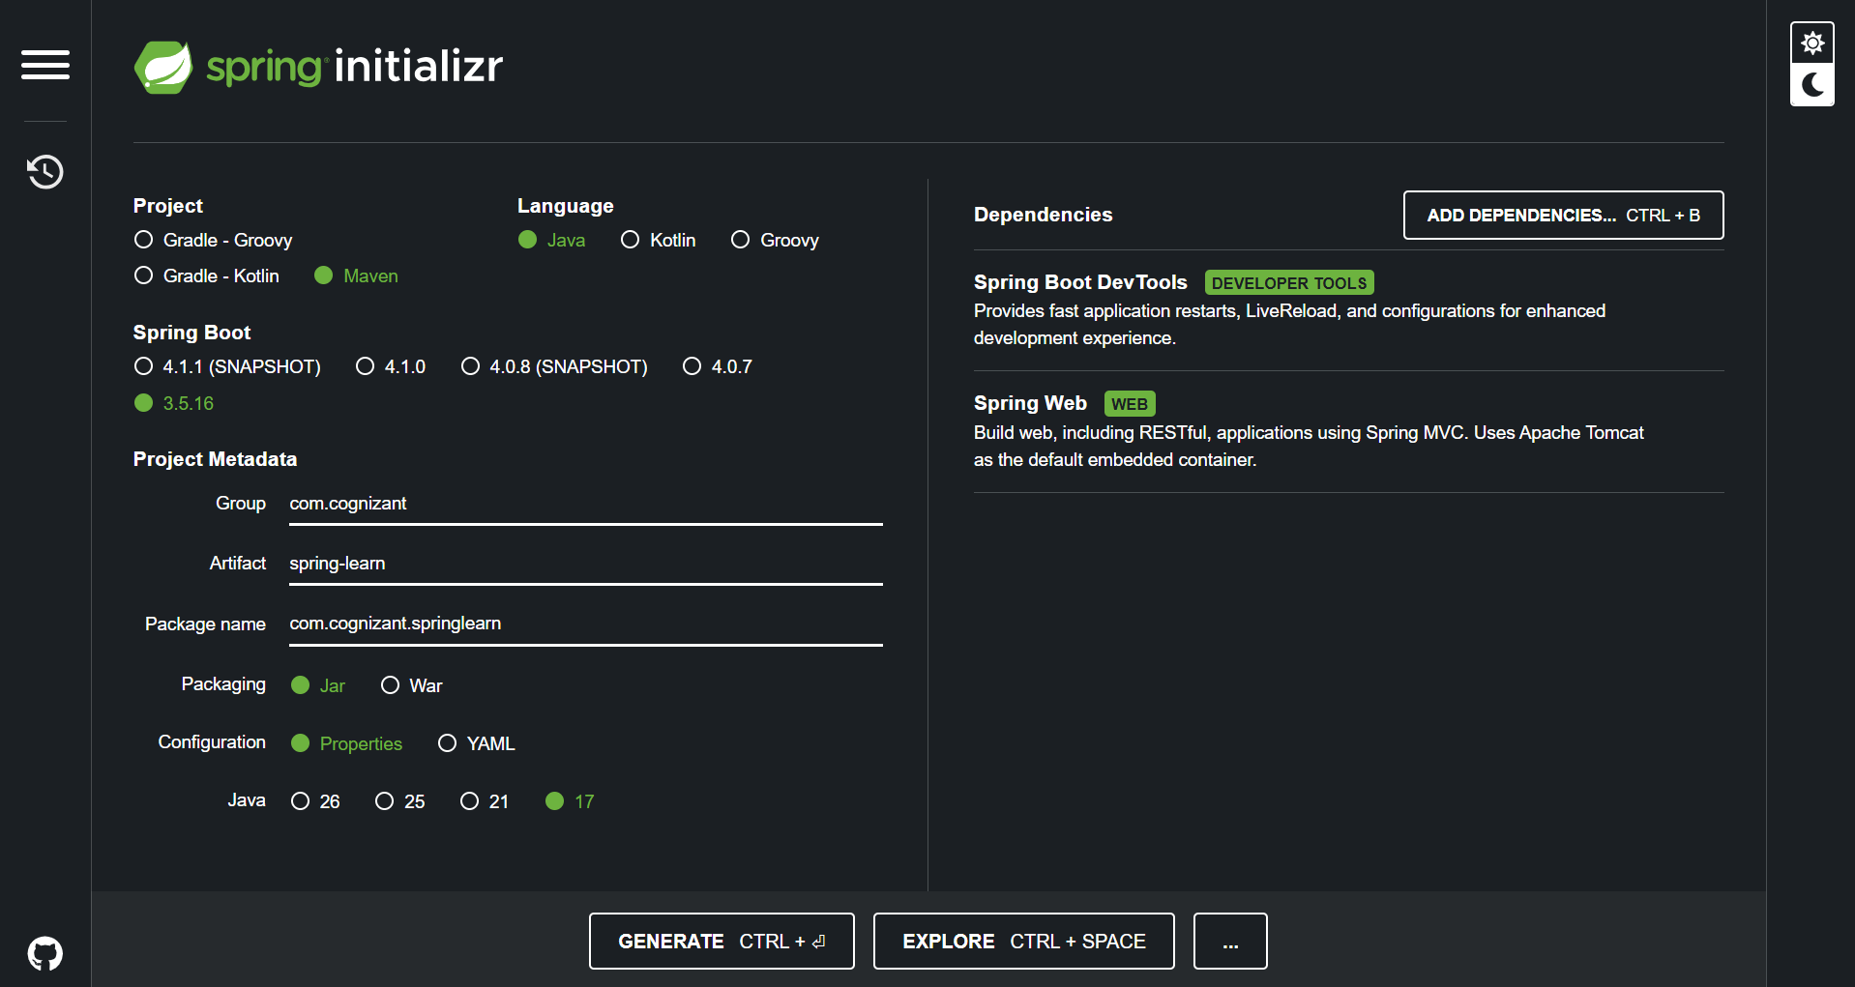

SpringLearnApplication.java
package com.cognizant.springlearn;
import org.springframework.boot.SpringApplication;
import org.springframework.boot.autoconfigure.SpringBootApplication;
@SpringBootApplication
public class SpringLearnApplication {
public static void main(String[] args) {
SpringApplication.run(SpringLearnApplication.class, args);
System.out.println("Spring Boot Application Started Successfully!");
}
}

Project Structure
- src/main/java - Contains Java source code.
- src/main/resources - Contains application.properties and configuration files.
- src/test/java - Contains test classes.
- SpringLearnApplication.java - Main class with the main() method.
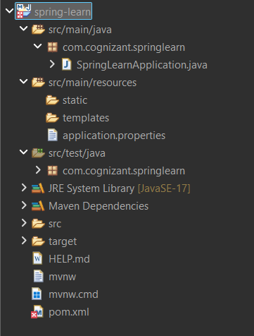

Console Output
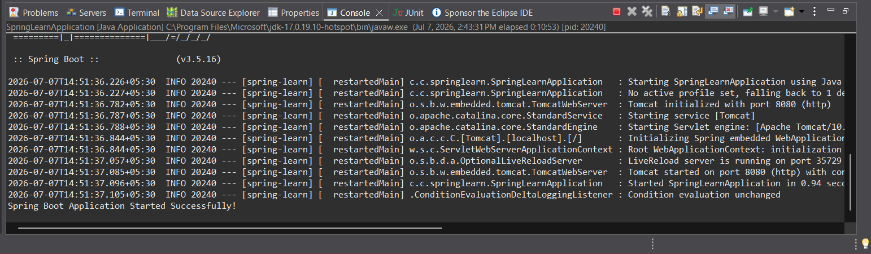

Conclusion
The Spring Boot web project was created using Maven, imported into Eclipse, built successfully, and executed without errors.

